EXERCISE – 1
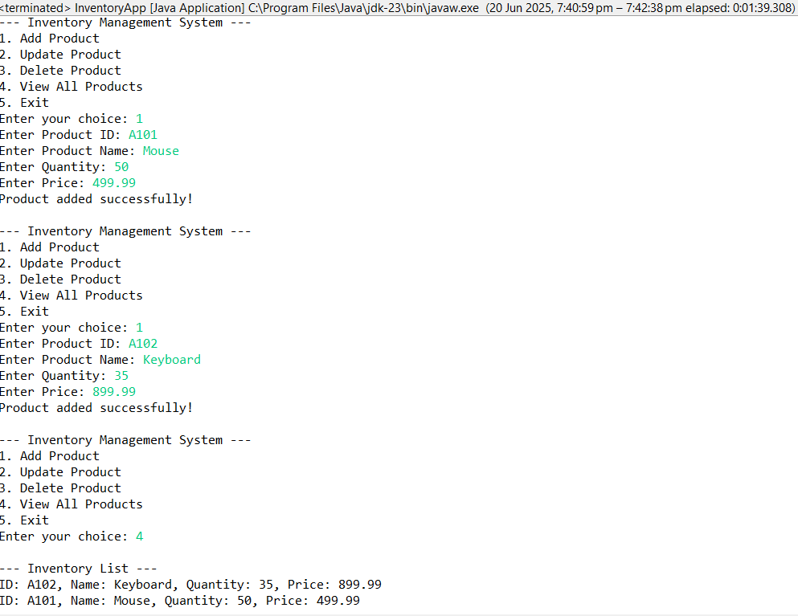

EXERCISE – 2
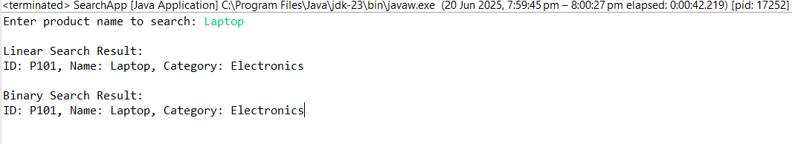
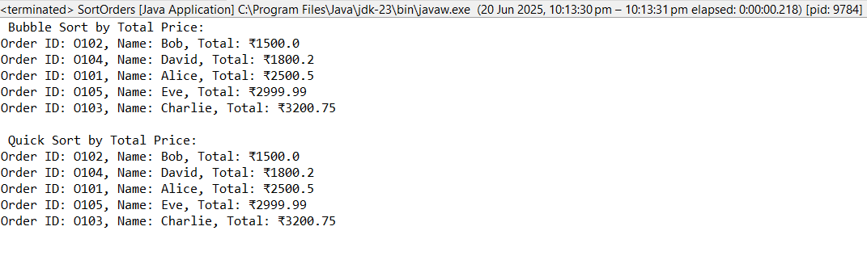
EXERCISE – 3

EXERCISE – 4
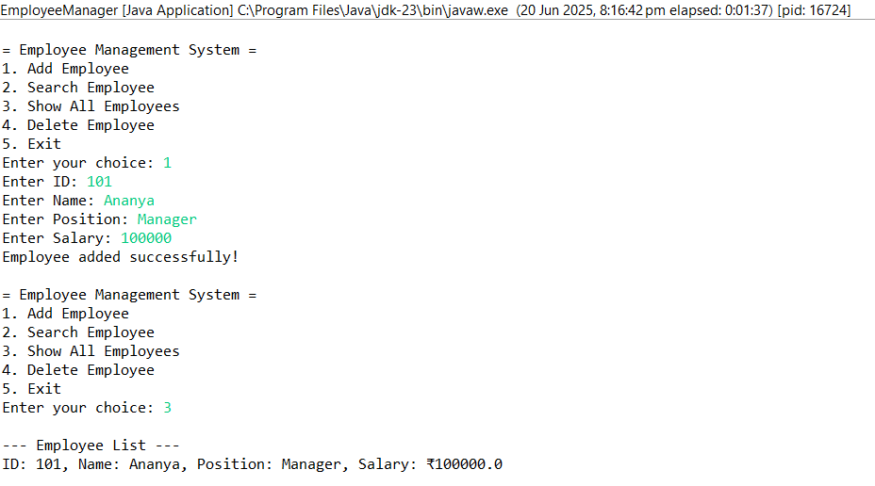

EXERCISE – 5
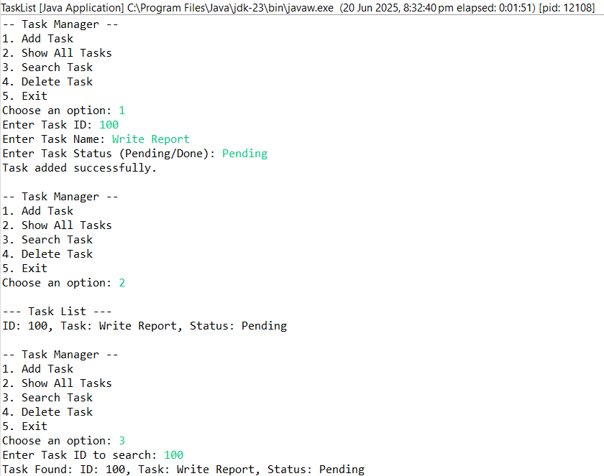

EXERCISE – 6
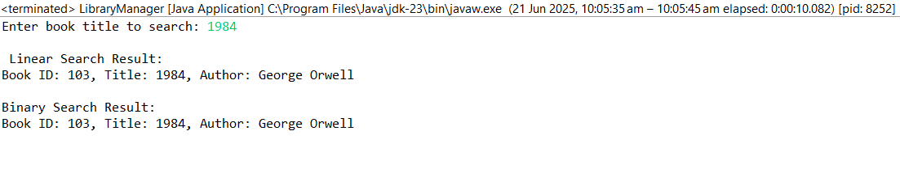
EXERCISE – 7
